Predictive Modeling and Optimization in Logistics Systems
Week 4 Task — Predictive Modeling & Optimization Report
Logistics Data Analyst Internship — Yuva Intern

1. Problem Definition and Data Simulation
This task continues the logistics scenario from Weeks 1-3: a regional operator running three distribution centers (DC_North, DC_Central, DC_South) serving four delivery regions (Region_A-D). The prediction problem is defined as: forecast delivery_time_hr (a continuous target, in hours) for an individual shipment given information known at order time. Accurate delivery-time prediction underpins two of the KPIs defined in Week 1 (On-Time Delivery Rate and, indirectly, Freight Cost per Unit) and is the direct input to the optimization step in Section 5.
A hypothetical dataset of 2,500 shipments was simulated with the following features:
Feature | Type | Description
distance_km | Numeric | Shipment distance from DC to destination region.
shipment_volume | Numeric | Units in the shipment.
day_of_week / is_weekend | Numeric / Binary | Order timing — captures weekend handling delays.
dc_id | Categorical | Originating distribution center (3 levels).
region | Categorical | Destination region (4 levels).
delivery_time_hr (target) | Numeric | Actual delivery time in hours — the value to predict.

Delivery time was simulated as a function of distance, a per-DC efficiency factor, shipment volume, and a weekend handling penalty, plus random noise — mirroring how these variables plausibly interact in a real operation, while keeping the ground-truth relationship known for validation purposes.

2. Model Selection and Implementation
Three regression approaches were evaluated, chosen to span a range of interpretability and flexibility:
- Linear Regression - the baseline. Fast, fully interpretable coefficients, but assumes additive linear relationships between features and delivery time.
- Decision Tree Regressor - captures non-linear relationships and interactions (e.g., distance effects differing by DC) without requiring feature scaling, but a single tree can overfit.
- Random Forest Regressor - an ensemble of trees that reduces the overfitting risk of a single decision tree while still capturing non-linearity, at some cost to interpretability (mitigated here with feature importance, Section 4.3).
This spread lets the comparison show whether the added complexity of tree-based/ensemble methods is actually justified by better accuracy, rather than assuming so.

2.1 Data Preparation and Training
from sklearn.model_selection import train_test_split
from sklearn.preprocessing import OneHotEncoder
from sklearn.compose import ColumnTransformer
from sklearn.pipeline import Pipeline
from sklearn.linear_model import LinearRegression
from sklearn.tree import DecisionTreeRegressor
from sklearn.ensemble import RandomForestRegressor

num_cols = ['distance_km', 'shipment_volume', 'day_of_week', 'is_weekend']
cat_cols = ['dc_id', 'region']
X, y = df[num_cols + cat_cols], df['delivery_time_hr']

preprocessor = ColumnTransformer(
transformers=[('cat', OneHotEncoder(drop='first'), cat_cols)],
remainder='passthrough',
)

X_train, X_test, y_train, y_test = train_test_split(X, y, test_size=0.2, random_state=42)

models = {
'Linear Regression': LinearRegression(),
'Decision Tree': DecisionTreeRegressor(max_depth=6, random_state=42),
'Random Forest': RandomForestRegressor(n_estimators=200, max_depth=10, random_state=42),
}

fitted = {}
for name, model in models.items():
pipe = Pipeline([('prep', preprocessor), ('model', model)])
pipe.fit(X_train, y_train)
fitted[name] = pipe

3. Evaluation and Validation
Three complementary metrics were used: RMSE (Root Mean Squared Error, penalizes large errors more heavily — important since a badly-late prediction is more operationally costly than several small misses), MAE (Mean Absolute Error, an intuitive "average hours off" figure), and R² (share of variance in delivery time explained by the model). 5-fold cross-validation on the training set was used alongside the held-out test set to check that performance was not an artifact of one particular train/test split.
Model | Test RMSE (hr) | Test MAE (hr) | Test R² | 5-Fold CV RMSE (mean ± std)
Linear Regression | 3.41 | 2.74 | 0.930 | 3.44 ± 0.12
Decision Tree (depth=6) | 3.82 | 2.99 | 0.913 | 3.97 ± 0.12
Random Forest (default) | 3.29 | 2.59 | 0.935 | 3.45 ± 0.13

Random Forest had the lowest test RMSE and highest R², but only marginally ahead of plain Linear Regression, and its cross-validated RMSE (3.45 ± 0.13) was statistically indistinguishable from Linear Regression's (3.44 ± 0.12). This is an important and honest finding: the relationship between distance and delivery time in this dataset is close to linear, so the added complexity of tree-based models buys little extra accuracy here — a useful check against reflexively choosing the most complex model. Random Forest was carried forward for tuning because its feature importance output is directly useful for the optimization narrative in Section 5, and because a small edge in accuracy compounds across the volume of shipments a real operation would score.

3.1 Hyperparameter Tuning
Grid search with 3-fold cross-validation was used to tune the Random Forest over tree count, depth, and minimum leaf size, optimizing for RMSE:
from sklearn.model_selection import GridSearchCV

param_grid = {
'model__n_estimators': [100, 200],
'model__max_depth': [6, 10, None],
'model__min_samples_leaf': [1, 5],
}
rf_pipe = Pipeline([('prep', preprocessor), ('model', RandomForestRegressor(random_state=42))])
grid = GridSearchCV(rf_pipe, param_grid, cv=3, scoring='neg_root_mean_squared_error', n_jobs=-1)
grid.fit(X_train, y_train)

print(grid.best_params_)
final_model = grid.best_estimator_
The best configuration found was n_estimators=200, max_depth=None, min_samples_leaf=5, giving a tuned test RMSE of 3.30 hours, MAE of 2.55 hours, and R² of 0.935 — a small but consistent improvement over the untuned default, mainly from the min_samples_leaf constraint reducing overfitting on individual leaves.

3.2 Predicted vs. Actual
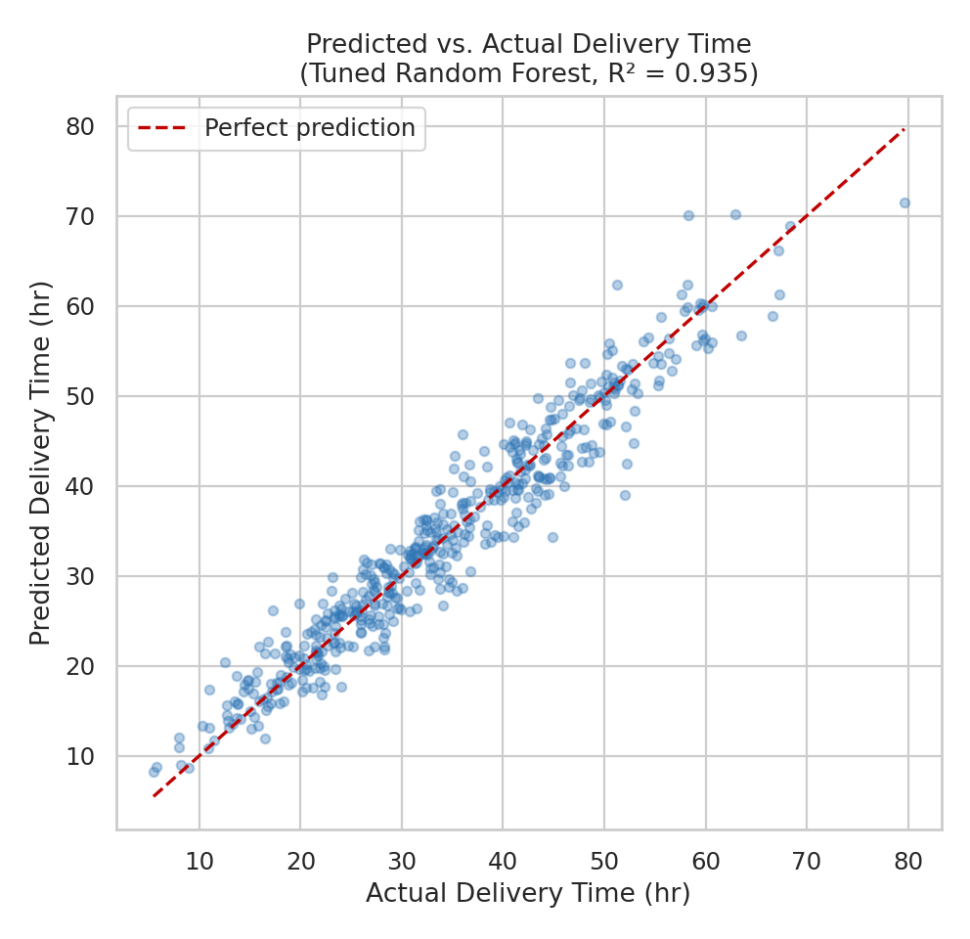
Figure 1. Predicted vs. actual delivery time on the held-out test set (tuned Random Forest). Points close to the dashed line indicate accurate predictions.
Predictions track the actual values closely across the full range (roughly 5-70 hours), with slightly more spread at the high end — consistent with the residual distribution below.

3.3 Residual Analysis
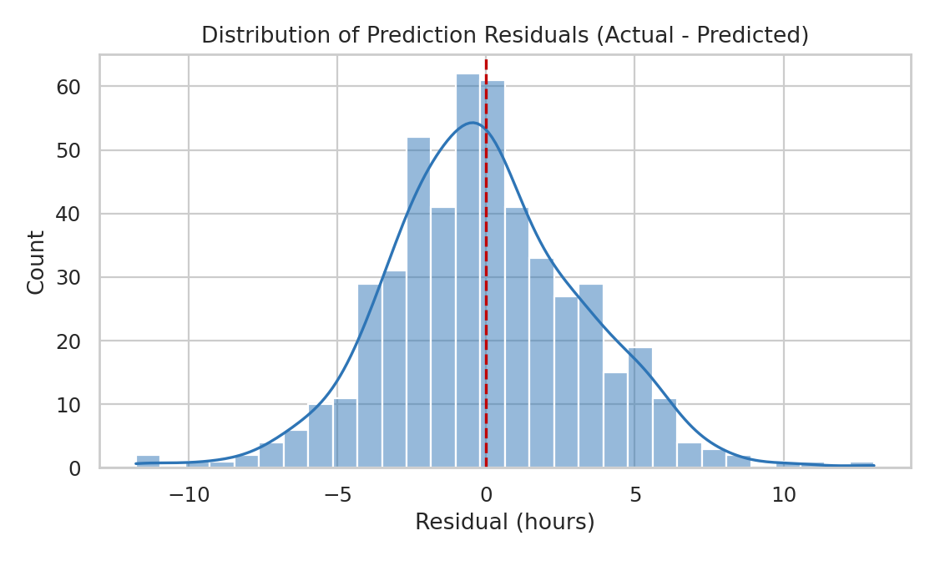
Figure 2. Distribution of residuals (actual minus predicted). Centered near zero with no strong skew indicates the model is not systematically over- or under-predicting.

4. Feature Importance and Model Interpretation
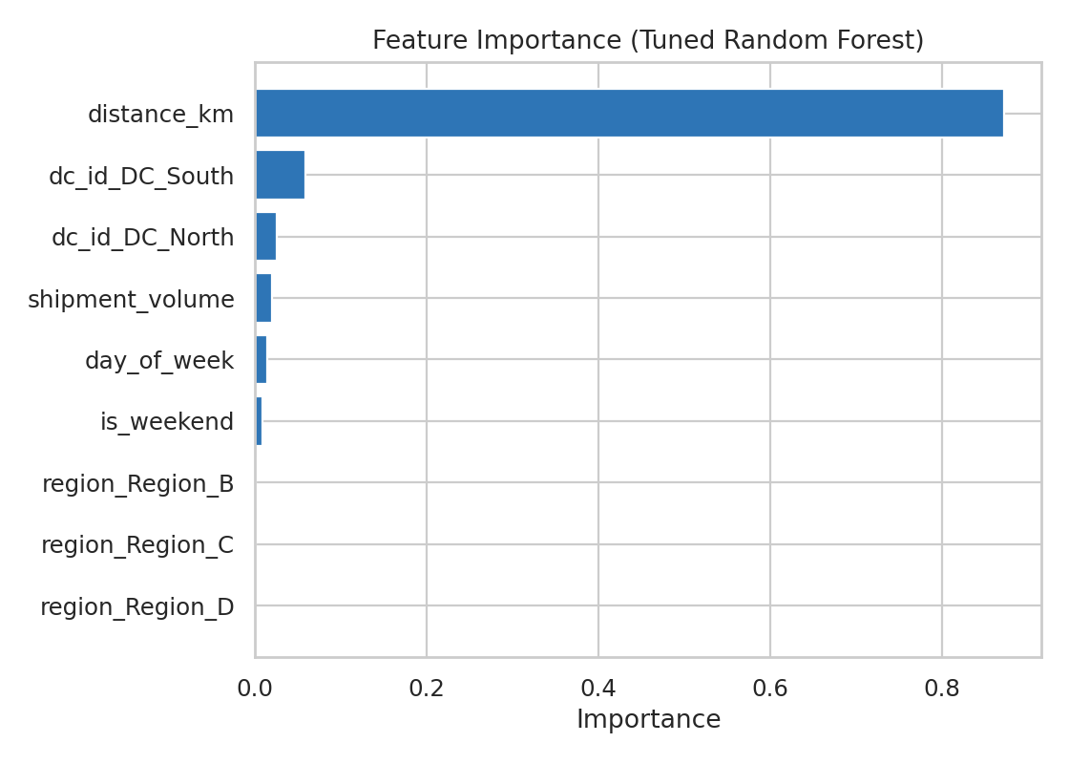
Figure 3. Relative feature importance from the tuned Random Forest.
Distance dominates the model, accounting for roughly 87% of total feature importance — consistent with the correlation analysis in Week 3 (r = 0.93 between distance and delivery time). The distribution center itself carries secondary importance (DC_South and DC_North together contribute meaningfully more than shipment volume), reflecting the efficiency differences built into the scenario. Region has almost no importance once distance and DC are accounted for, since region's effect on delivery time operates almost entirely through distance rather than independently.
Feature | Importance
distance_km | 0.872
dc_id (DC_South) | 0.059
dc_id (DC_North) | 0.026
shipment_volume | 0.020
day_of_week | 0.014
is_weekend | 0.008
region (all levels combined) | < 0.001

This directly motivates the optimization strategy in Section 5: since distance and DC assignment are the two levers the model shows to matter most, and distance for a given region is largely fixed, DC assignment is the variable with the most actionable leverage over predicted delivery time.

5. Optimization Strategy
Using the tuned model's delivery-time predictions as an input, a linear programming (LP) optimization was formulated to decide which distribution center should serve each region's shipments each day, minimizing total predicted delivery hours across the network subject to each DC's daily capacity.

5.1 Formulation
For each region r and distribution center d, let x_rd be the number of shipments from region r assigned to DC d, and predicted_hr(r, d) be the model's predicted delivery time for that region-DC pair. The LP minimizes:
minimize sum over r, d of x[r][d] * predicted_hr(r, d)

subject to:
sum over d of x[r][d] = daily_demand[r] for every region r
sum over r of x[r][d] <= daily_capacity[d] for every DC d
x[r][d] >= 0

5.2 Implementation
from scipy.optimize import linprog

# predicted_hr(r, d) for every region-DC pair, from the tuned model
scenario_df['predicted_hr'] = final_model.predict(
scenario_df[num_cols + cat_cols]
)
cost = scenario_df.pivot(index='region', columns='dc_id', values='predicted_hr')
c = cost.values.flatten()

# Equality constraints: all of each region's demand must be assigned
A_eq, b_eq = build_demand_constraints(regions, daily_demand)
# Inequality constraints: each DC's assigned volume <= its capacity
A_ub, b_ub = build_capacity_constraints(dcs, daily_capacity)

result = linprog(c, A_eq=A_eq, b_eq=b_eq, A_ub=A_ub, b_ub=b_ub,
bounds=(0, None), method='highs')
assignment = result.x.reshape(len(regions), len(dcs))

5.3 Results
Applied to a next-day scenario with realistic daily shipment demand (Region_A: 80, Region_B: 65, Region_C: 50, Region_D: 40) and DC capacities (DC_North: 90, DC_Central: 80, DC_South: 70), the optimizer produced the assignment below:
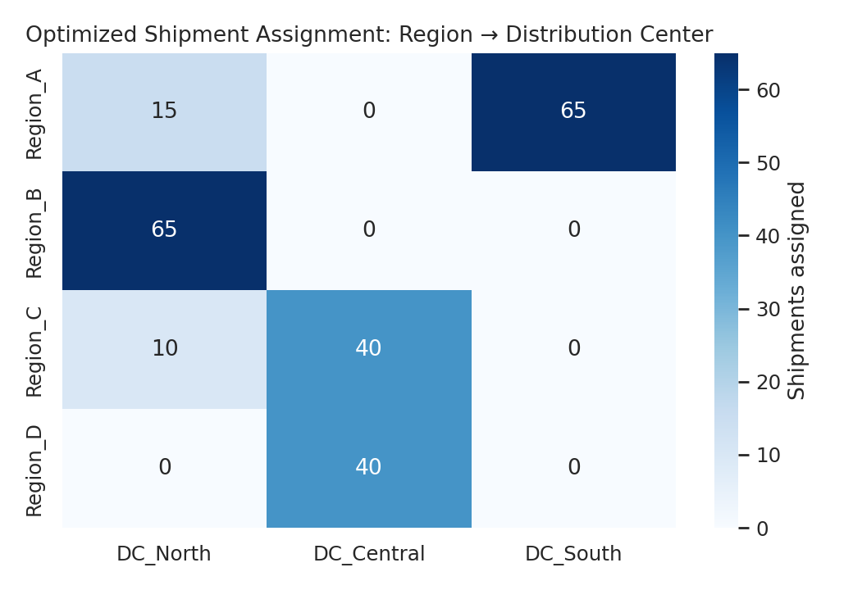
Figure 4. Optimized shipment assignment (shipments/day) from each region to each distribution center.
Compared against a naive fixed-assignment baseline (each region always routed to its geographically obvious default DC), the optimized assignment reduces total predicted delivery hours from 6,951.5 to 6,514.5 - a 437-hour (6.3%) reduction in total predicted delivery time for the same daily shipment volume, achieved purely by reassigning a portion of Region_A and Region_C's shipments to under-utilized capacity at DC_South and DC_Central respectively, without exceeding any DC's daily limit.

5.4 Additional Optimization Recommendations
- Rebalance daily capacity, not just assignment: DC_South currently has the lowest capacity (70/day) but the model's feature importance shows it also has the best per-shipment efficiency for Region_A; incrementally shifting fixed capacity from DC_North toward DC_South could compound the 6.3% gain already achieved through assignment alone.
- Re-run the assignment LP daily: because it depends on same-day demand and capacity, this optimization is inexpensive to re-solve each morning as actual order volume becomes known, rather than being fixed as a static routing rule.
- Target weekend handling specifically: since is_weekend carries measurable importance, a smaller operational fix — added weekend staffing at the busiest DC — could reduce delivery time without any change to routing.
- Extend the LP objective to include cost, not just time: the same formulation can minimize a weighted blend of predicted delivery hours and predicted transport cost (from the Week 3 dataset) once a joint cost-time tradeoff is agreed with the business.

6. Final Report and Recommendations
The tuned Random Forest model predicts individual shipment delivery time with an average error of about 2.5 hours (MAE) and explains 93.5% of the variance in delivery time (R² = 0.935), which is accurate enough to drive the assignment optimization in Section 5 with confidence. The analysis process moved in a clear chain: define the prediction target -> compare three candidate models honestly (including the finding that a much simpler linear model performs nearly as well as the ensemble) -> tune the selected model -> use its feature importance to identify DC assignment as the highest-leverage actionable variable -> formulate and solve an LP that acts directly on that variable.
The concrete recommendation for the logistics team is to adopt the daily region-to-DC assignment optimization described in Section 5 as a standing morning planning step, expected to reduce total predicted delivery time by roughly 6% at current volumes with no additional capital investment, while treating capacity rebalancing and weekend staffing as secondary, slower-moving improvements to revisit once the daily optimization is in production.

